**Jaypee Institute Of Information And** **Technology Noida**

**Department of CSE &IT**

**B.Tech III Semester**



UNDER SUPERVISION OF:

**DR. INDU CHAWLA**

**ASSISTANT PROFESSOR (SENIOR GRADE)**

**SUBMITTED BY: -**

ADITI JAIN (20103273)

TANUPRIYA PATHAK

(20103288)

BATCH: -B10

# CERTIFICATE

This is to certify that “**ADITI JAIN, TANUPRIYA PATHAK”** of Batch B10 of **JAYPEE INSTITUTE OF INFORMATION AND TECHNOLOGY**, Noida sector-62 has successfully completed this **Database Systems and Web** prescribed by **Dr. Indu Chawla**, during 3rd semester 2021.

*SIGNATURE*

Dr Indu Chawla

*SUPERVISOR*

## Acknowledgement

We are very grateful and thankful to our professor

**Dr Indu Chawla** who gave us good guidance and suggestions about each and every topic which we have studied and researched.

We are also thankful to our friends who gave us support in completing this project and solve all our difficulties. We are taking this opportunity to express our gratefulness to the HOD sir.

We also express our heartily thankfulness to all our friendly batchmates and those who have helped us in the preparation of this project. And finally we thank God who made all things possible.

LIT.HUB

“Getting high on knowledge”

Knowledge is having the right answer and Intelligence is asking the right question.

Lit.hub brings a platform in support of freshly emerging computer science undergraduates with their uplifted spirits to conquer the tech world as well as our most talented and experienced engineers or to be Engineers from all over the tech depths to extend a helping hand towards our newbies.

Finding a mentor in initial days of college is one of the most difficult tasks to be executed by a freshly entered graduate. Students face lack of awareness on how to have a firm grip of all the responsibilities ranging from getting used to college’s ecosystem to upgrading skillsets for a smooth transition into the tech world.

Situations got worse as the world was hit by a seemingly never-ending pandemic and forced student to take this journey in action from their very own homes depriving them from the needed exposure.

As our vision says “getting high on knowledge”, our virtual ecosystem

brings this facility at everyone’s doorstep.

**Introduction:-**

### We have used

HTML/CSS/Bootstrap/PHP/MySQL for making this project. The software that we have used is Xampp and VS Code(as text editor).

**ER Diagram:-**

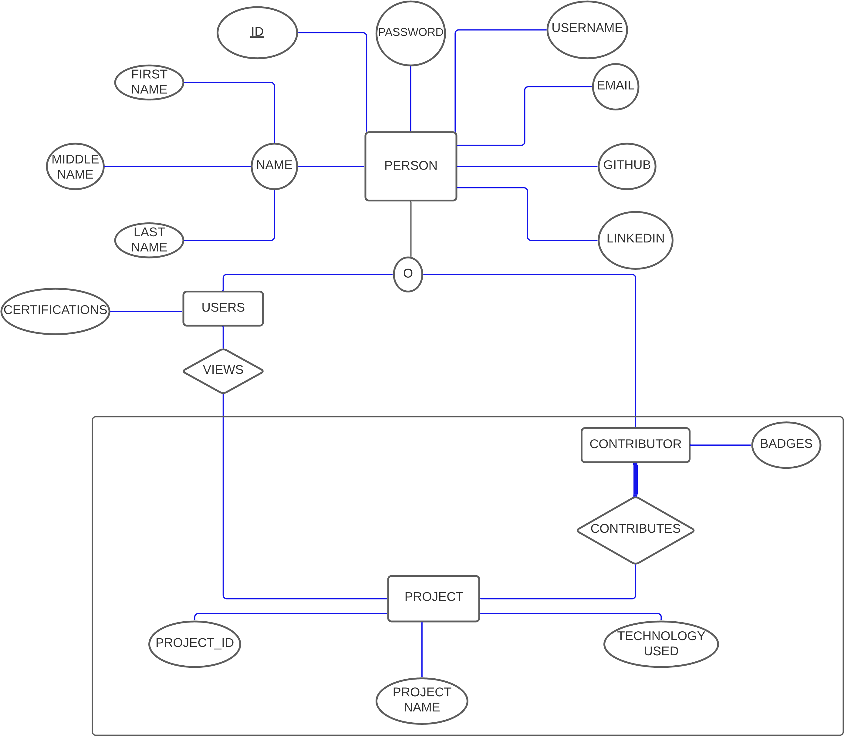

**Output**

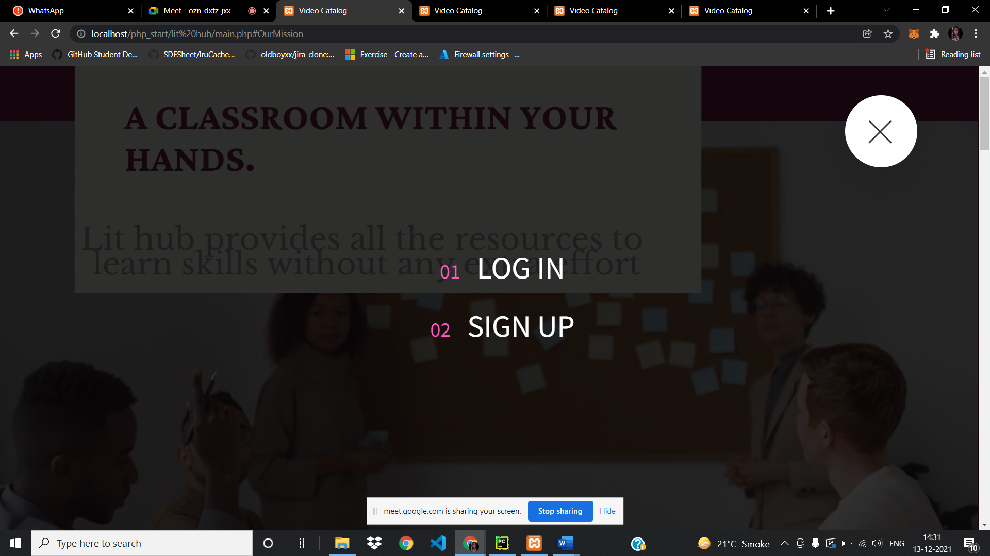

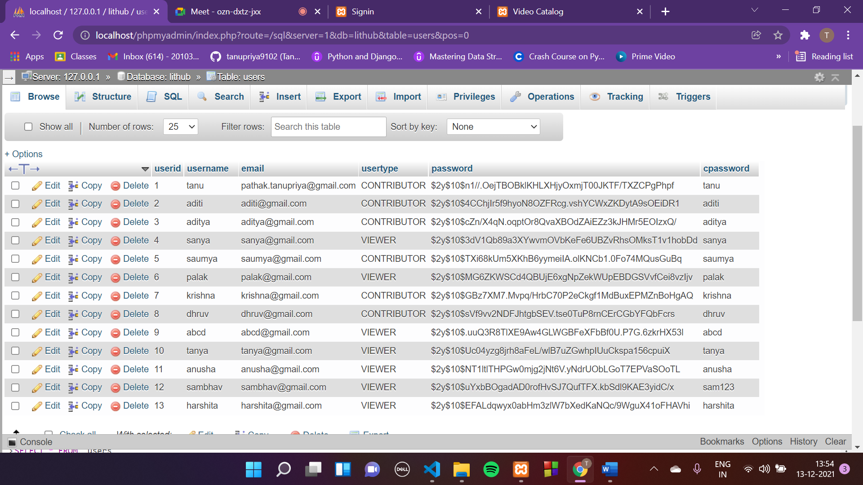



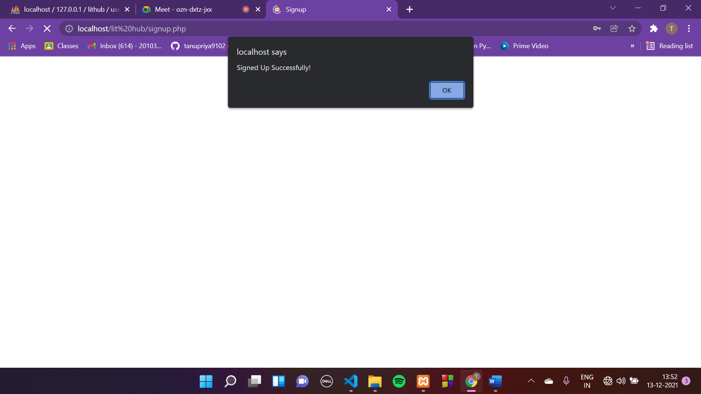

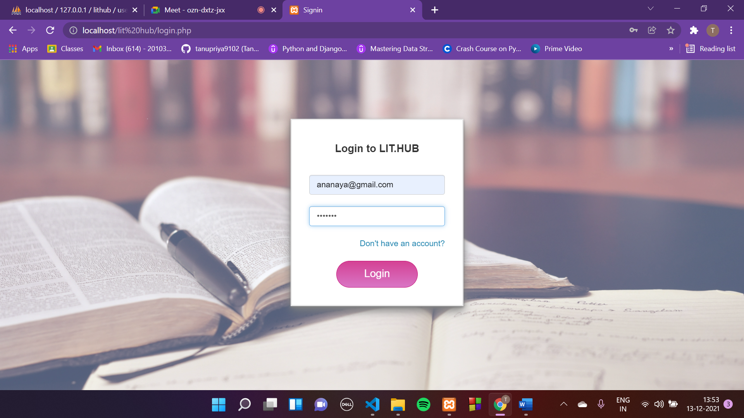







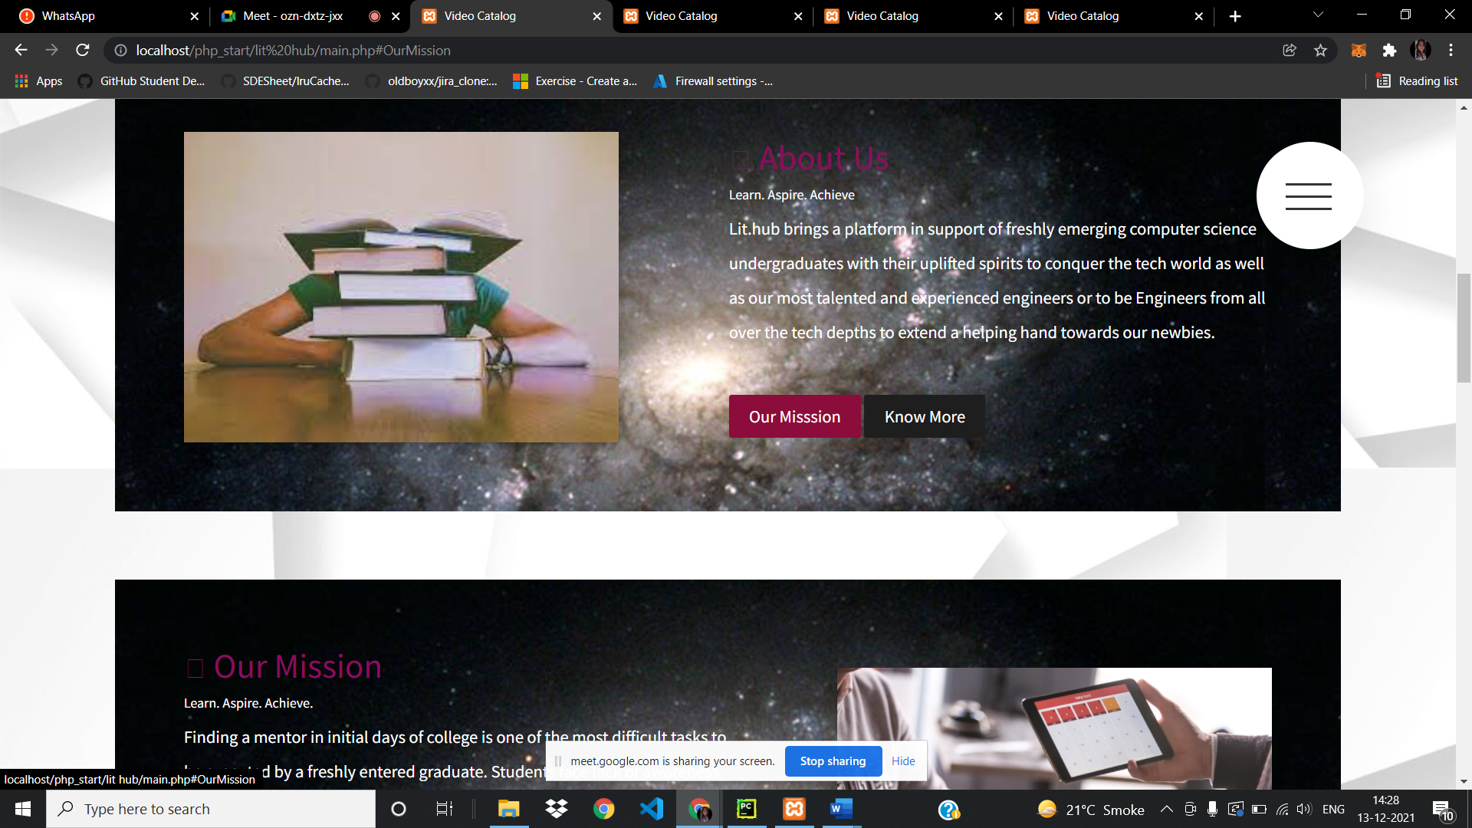

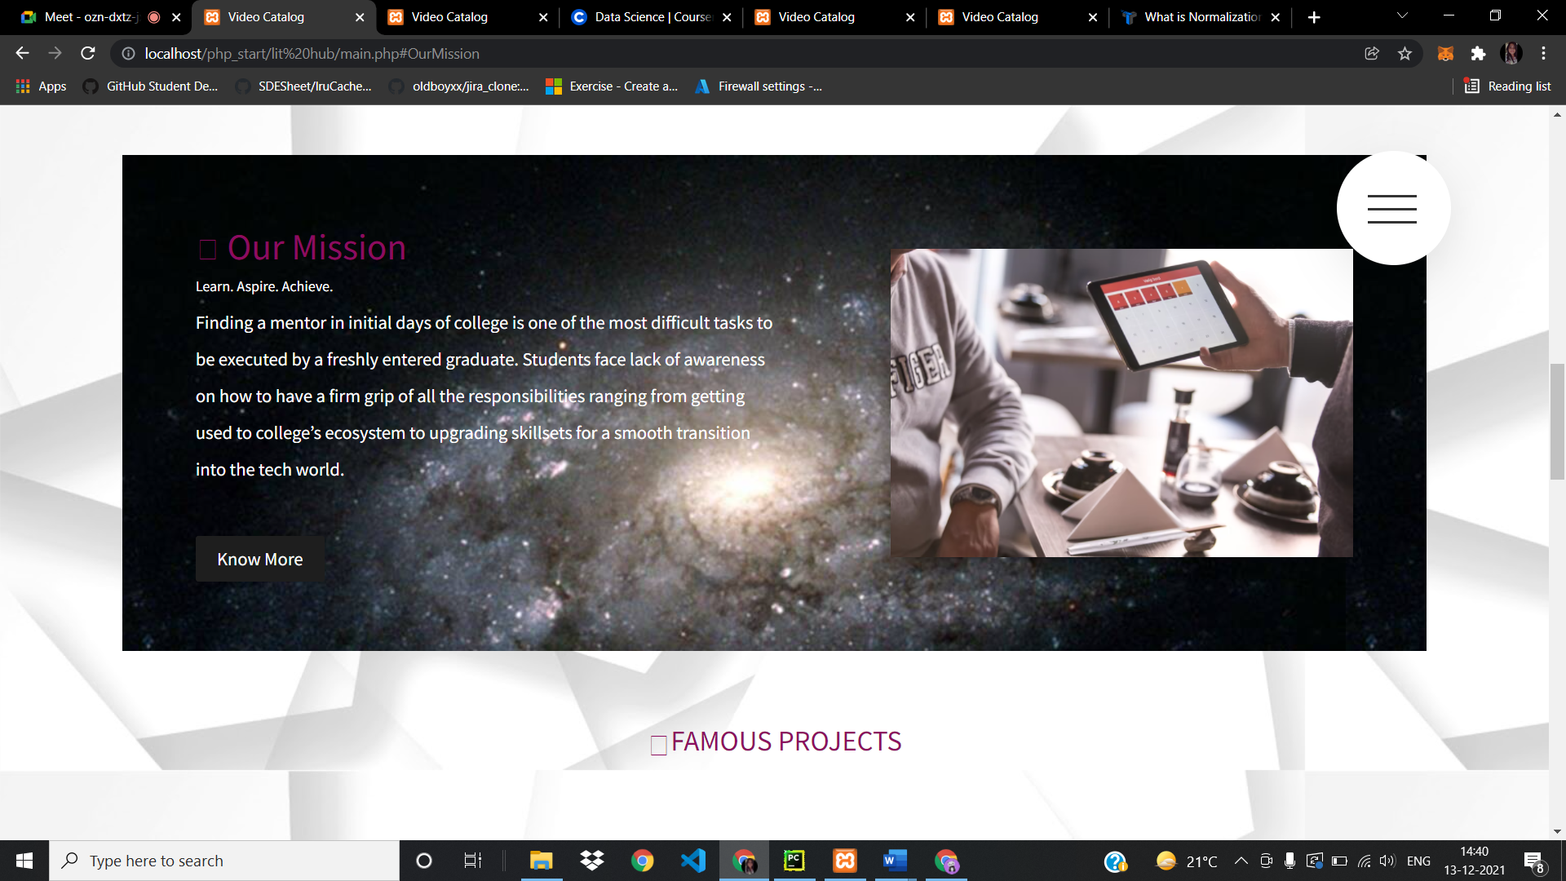

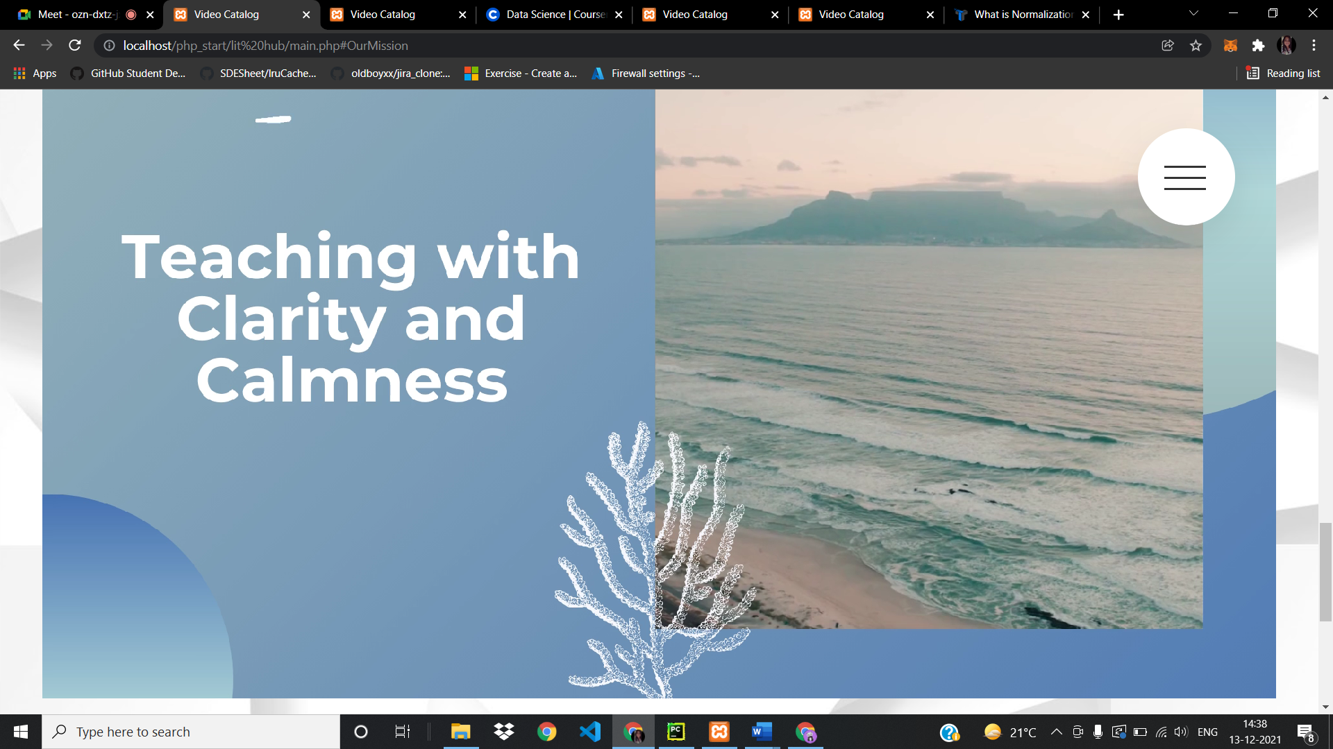

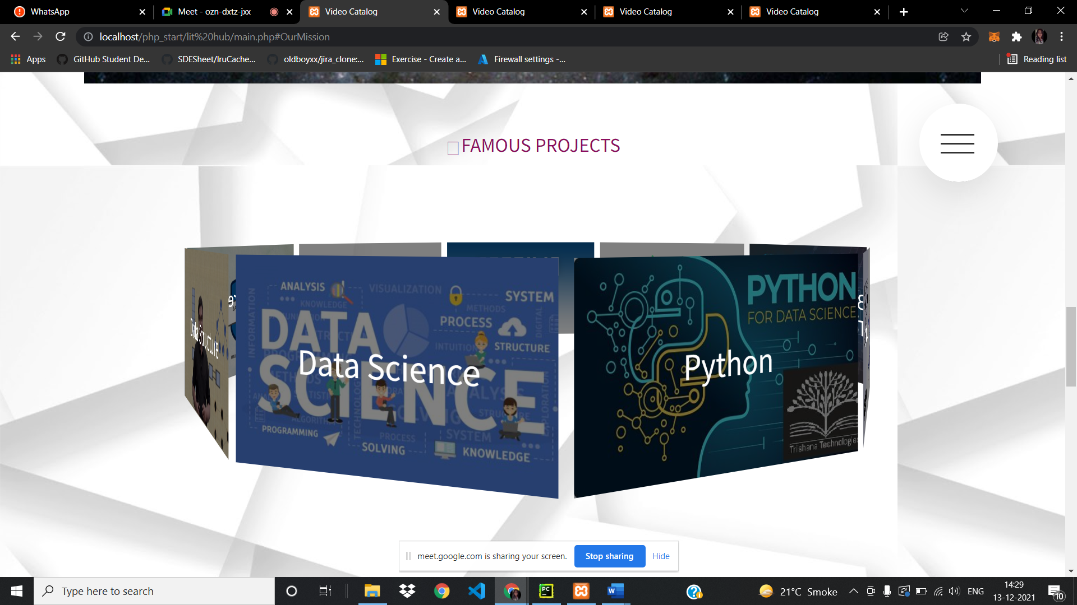

VIDEOS PAGE:

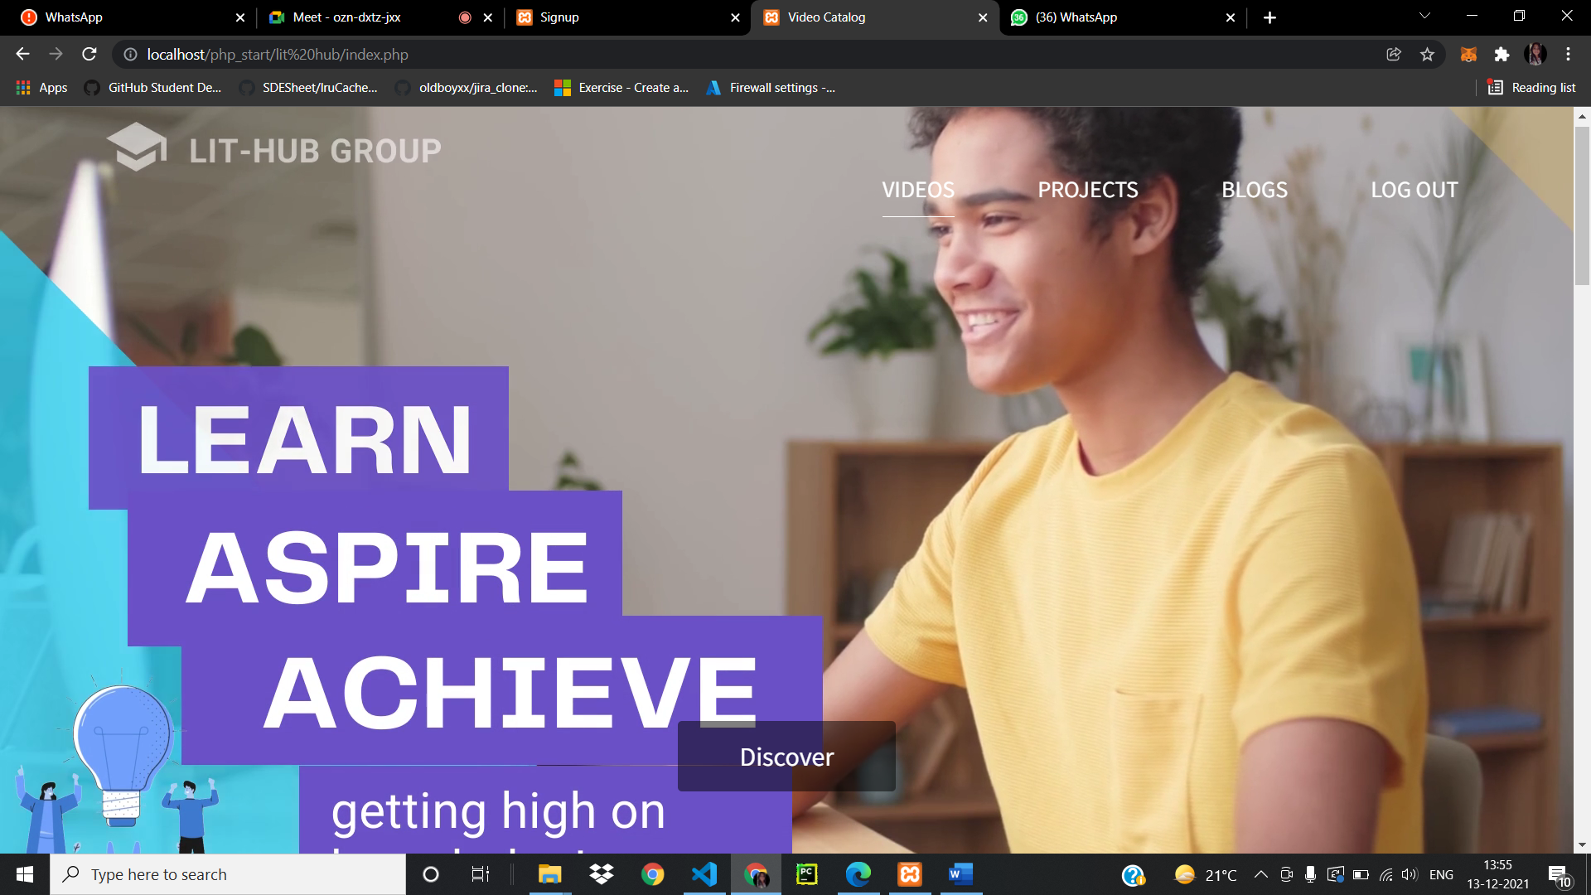



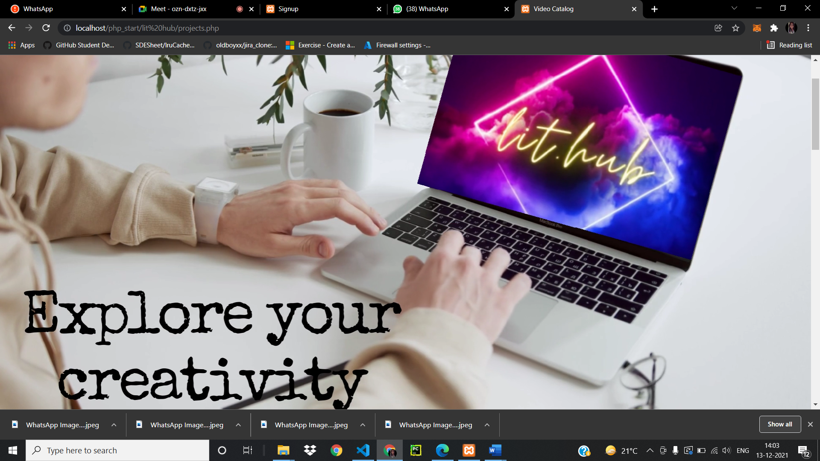

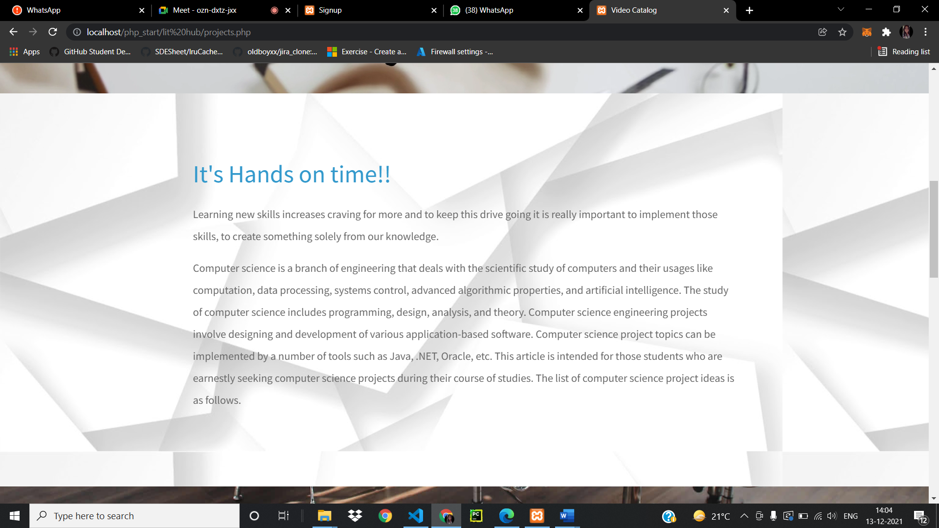

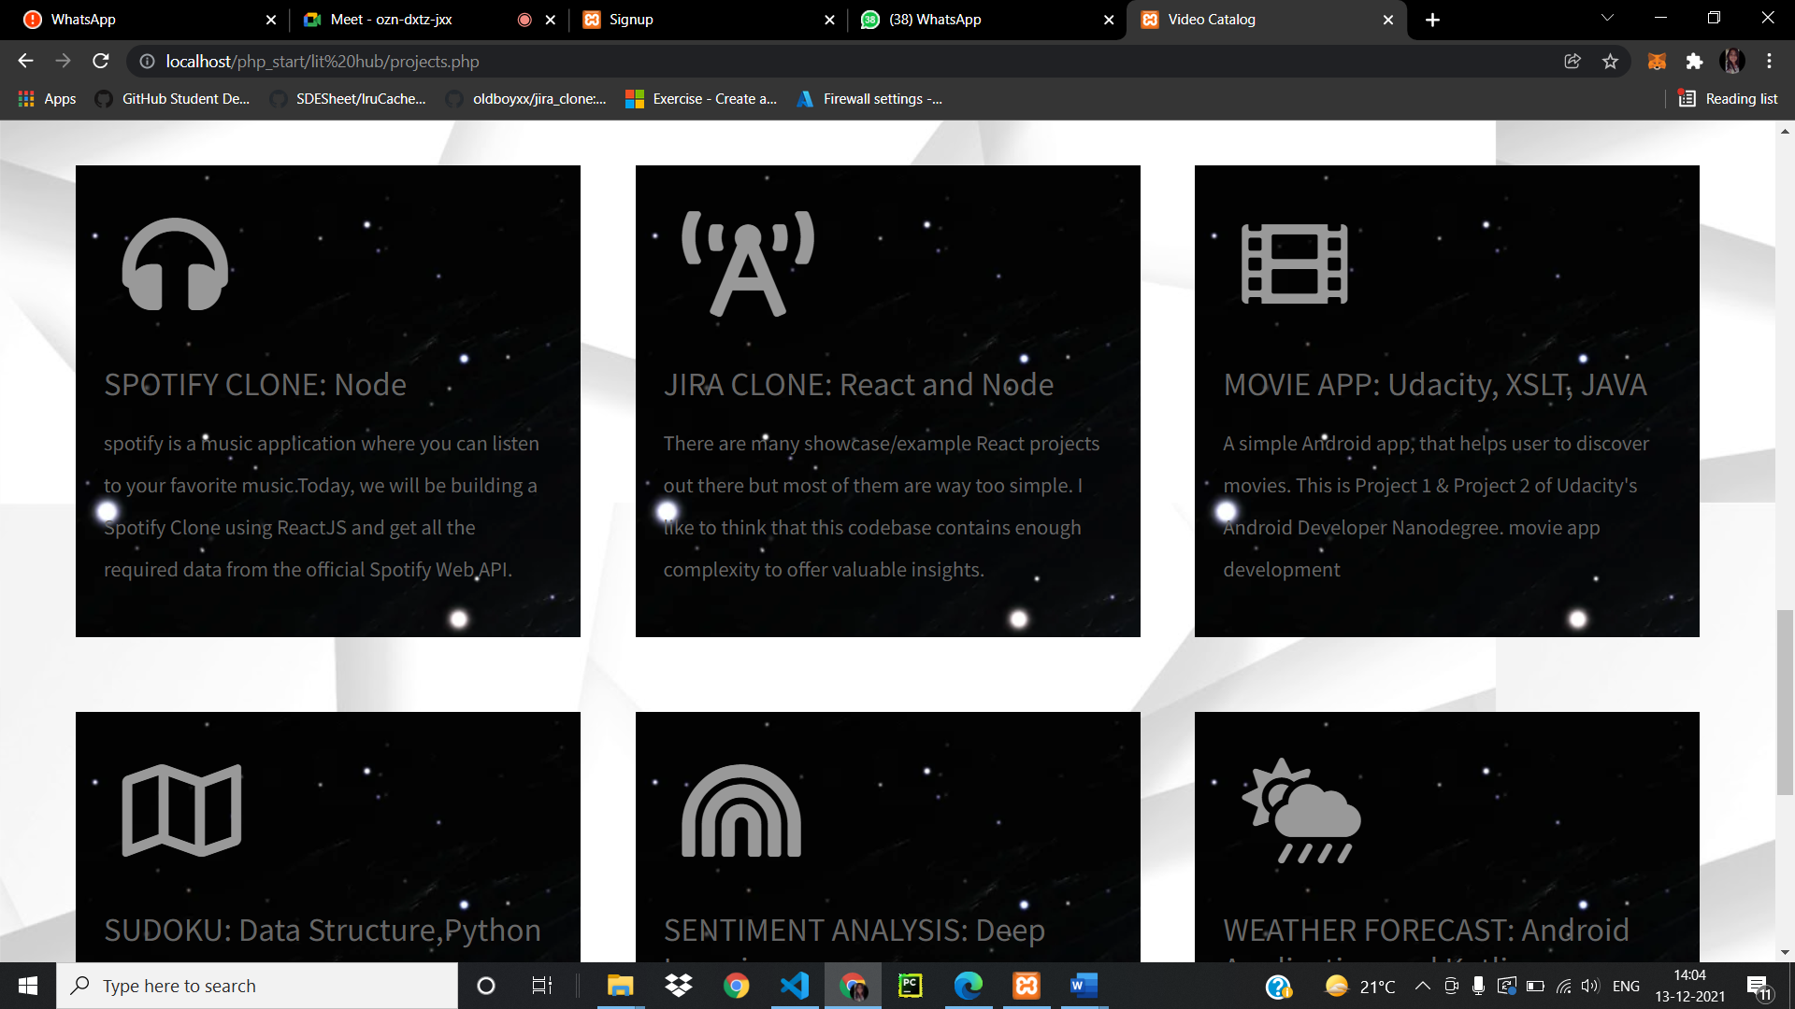

BLOGS PAGE:

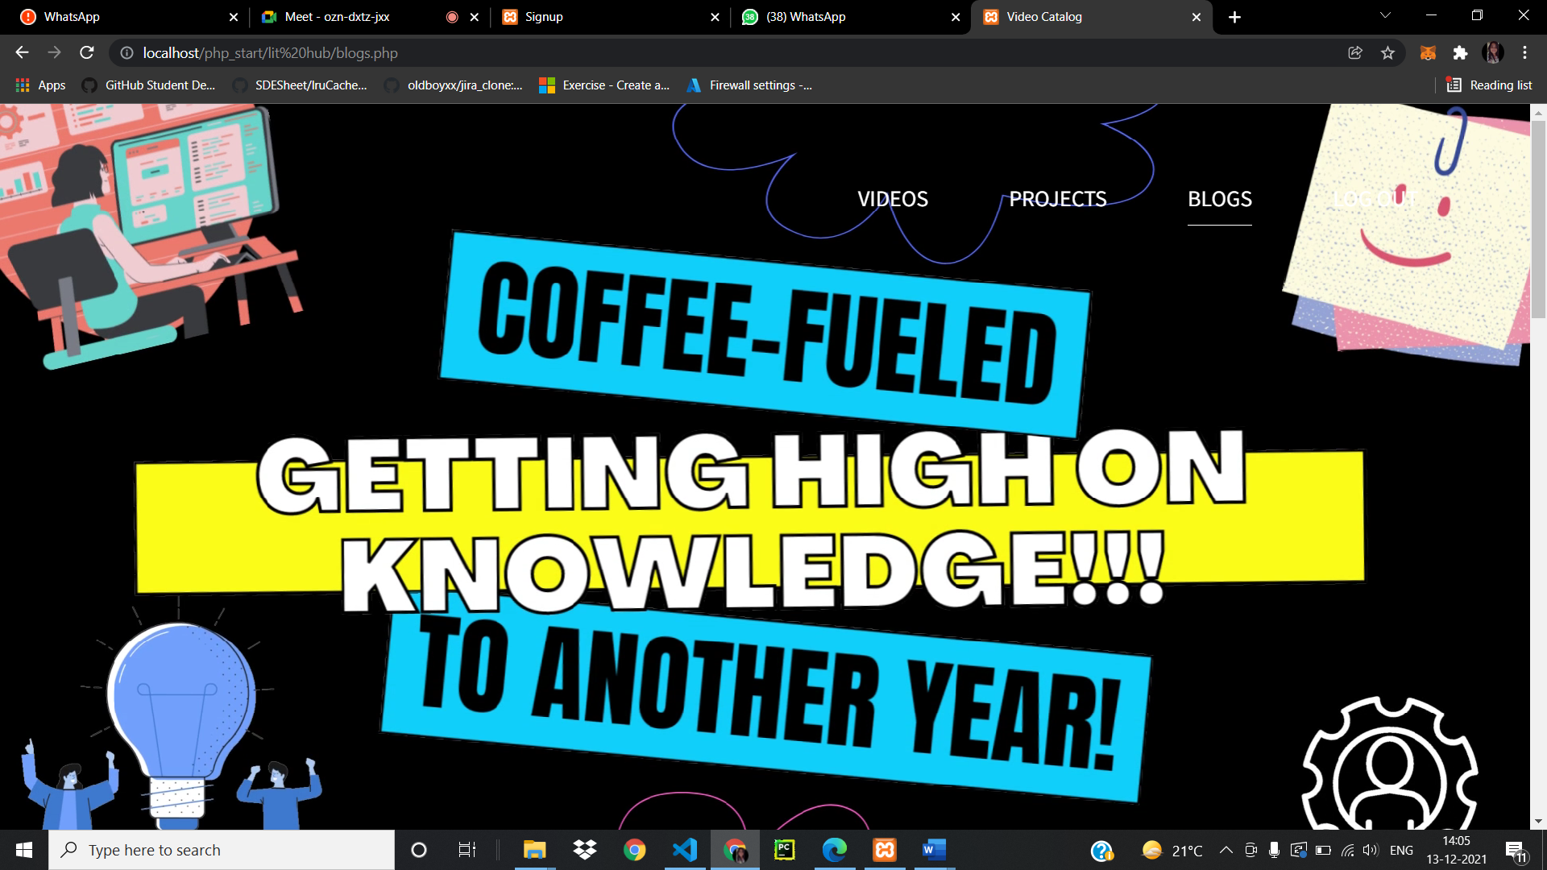

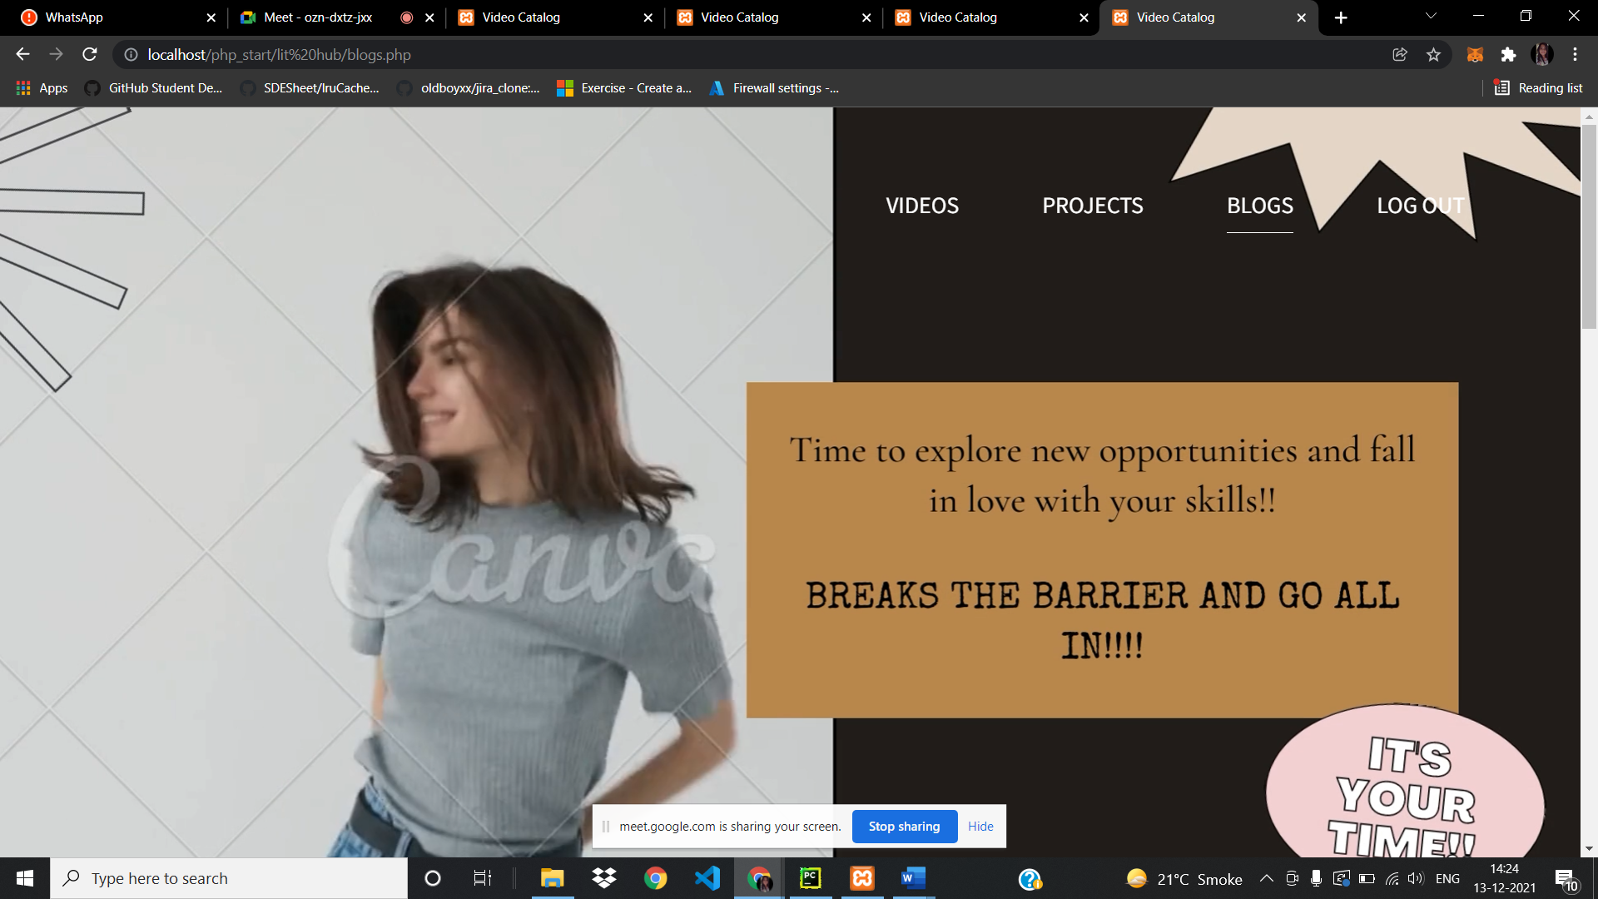

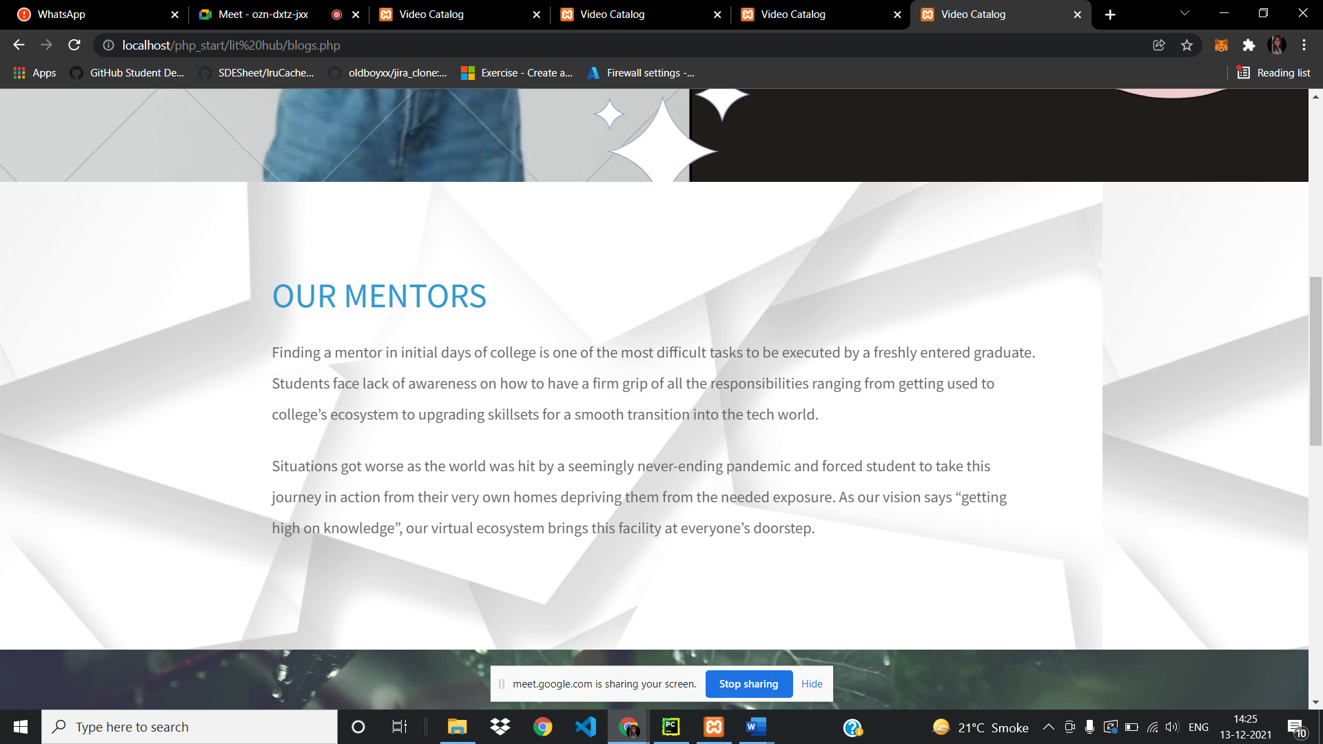

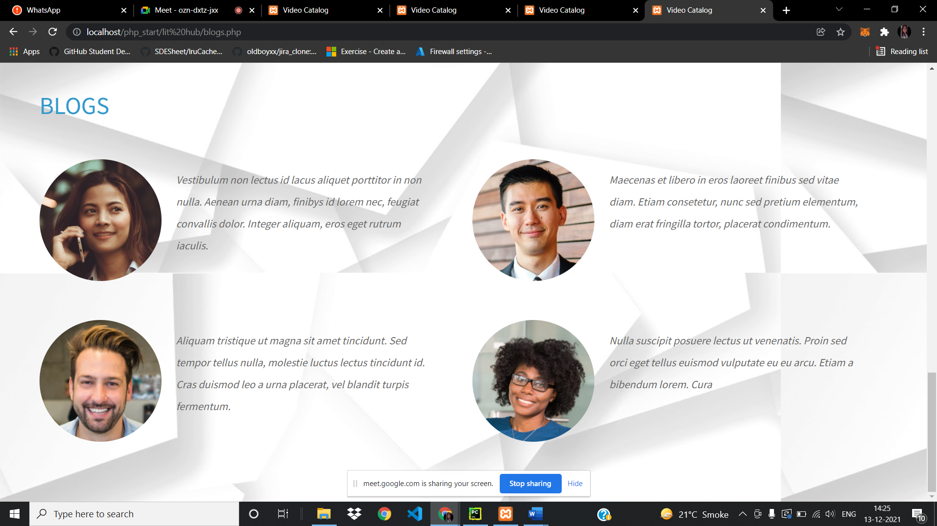

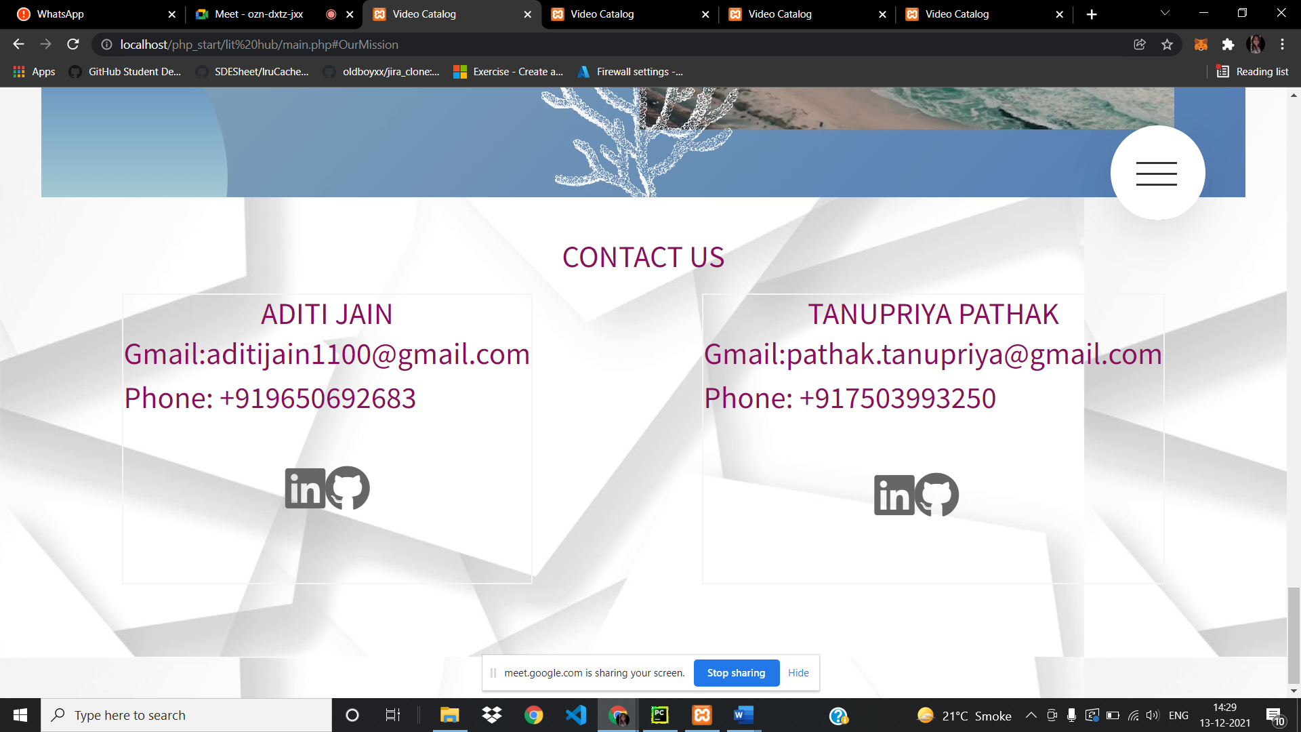

NORMALIZATION:

Normalization is the process of reorganizing data in a database so that it meets two basic requirements:

1. There is no redundancy of data, all data is stored in only one place.
2. Data dependencies are logical,all related data items are stored together.

Normalization is important for many reasons, but chiefly because it allows databases to take up as little disk space as possible, resulting in increased performance.

Normalization is also known as data normalization

Viewers and contributors in different tables listed along with their username.

FUTURE VISION OF THE PROJECT:

Here we will be implementing a Group Discussion were the contributors and viewers will be able to converse with each other.  
followed by ability to upload new projects.

Under the Guidance of:

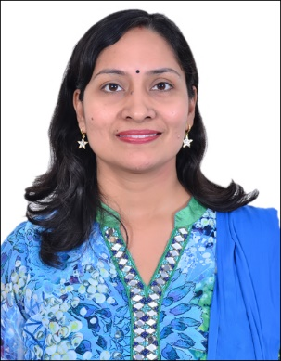

Dr. Indu Chawla (Assistant Professor Senior Grade)

REFRENCES:

1. GitHub (for specified projects)
2. YouTube (for specified courses)
3. Canva (video designing)